- Q1.py Question 1 — Movie Ratings (Lists and Strings)
Approach :
- 4 functions created as instructed
- parse_ratings (data: str)
Used split() to separate the ratings string into individual movie-rating entries.
Used strip() to remove extra spaces around movie names and ratings while parsing the ratings data
Converted ratings to integers and stored them as (movie, rating) tuples in a list.
- average_rating(ratings, title)
Used list comprehensions, sum(), and len() to calculate the average rating for each movie.
- best_movie(ratings)
Used a set to collect unique movie titles and identify the best-rated movie.
- rating_counts(ratings)
Used a dictionary to count how many ratings each movie received.
Demo Output:
print("Parsed ratings:", ratings)
print("Average rating for Dune:", average_rating(ratings, "Dune"))
print("Average rating for Barbie:", average_rating(ratings, "Barbie"))
print("Average rating for Oppenheimer:", average_rating(ratings, "Oppenheimer"))
print("Average rating for None:", average_rating(ratings, "None"))
print("Best movie:", best_movie(ratings))
print("Rating counts:", rating_counts(ratings))
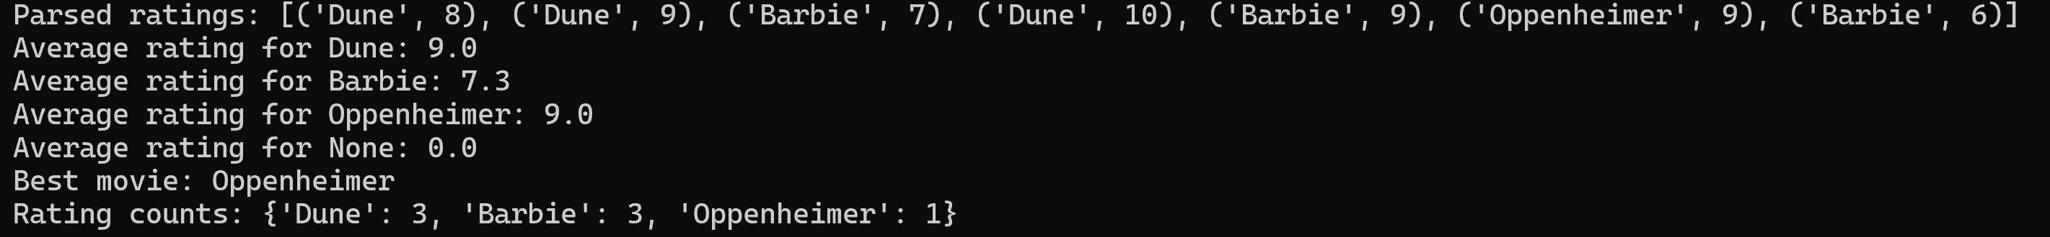
Problem ran into: None

- Q2.py Gradebook (Dictionaries and Sets)
Approach :
- Used grades.items() to iterate through subjects and student records.
- subjects_of(student)
Used a set and add() to find all subjects taken by a student.
- takes_all(grades)
Used list comprehension and set.intersection() to find students enrolled in every subject.
- student_average(grades, student)
Used a list, append(), sum(), and len() to calculate a student's average grade.
- honor_roll(grades, limit=1.5)
Used a set and update() to collect all unique students across subjects.
Used sorted() to return the honor roll list in alphabetical order.
Demo Output:
print("Demo... ")
print("Subjects of anna:", subjects_of("anna"))
print("Subjects of ben:", subjects_of("ben"))
print("Students taking all subjects:", takes_all(grades))
print("Anna's average:", student_average(grades, "anna"))
print("Ben's average:", student_average(grades, "ben"))
print("Unknown student's average:", student_average(grades, "eva"))
print("Honor roll:", honor_roll(grades))
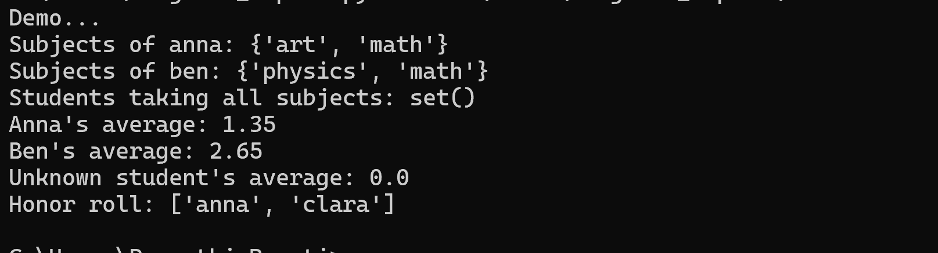
Problem ran into: None

- Q3.py Recipe Scaler (Functions)
Approach :
- Create scale_recipe(name, servings, *ingredients, unit="g", **options)
- Used *ingredients to accept a variable number of ingredients as tuples.
- Used **options to accept optional cooking notes such as time and style.
- Used a for loop to iterate through ingredients and scale each quantity based on the number of servings.
- Used a dictionary to store the scaled ingredient amounts.
- Used an if statement to validate that servings are at least 1 and handle invalid input.
- Used options.items() to display additional cooking notes when provided.
Demo Output:
print("Demo.... ")
# Simple recipe
print(scale_recipe("chocolate cake",4,("All purpose", 100),("Milk", 200),("Sugar", 20),("coco powder", 20)))

# Different unit
print(scale_recipe("Lemonade", 3,("Water", 250),("Lemon Juice", 50),unit="ml"))

# Several options
print(scale_recipe("Biryani",2,("Rice", 300),("Masala", 150),("Ghee", 100),("Onions", 100),time="60min",Style="Dum"))

# Invalid servings
print(scale_recipe("dessert",0,("Flour", 200),("Sugar", 100)))
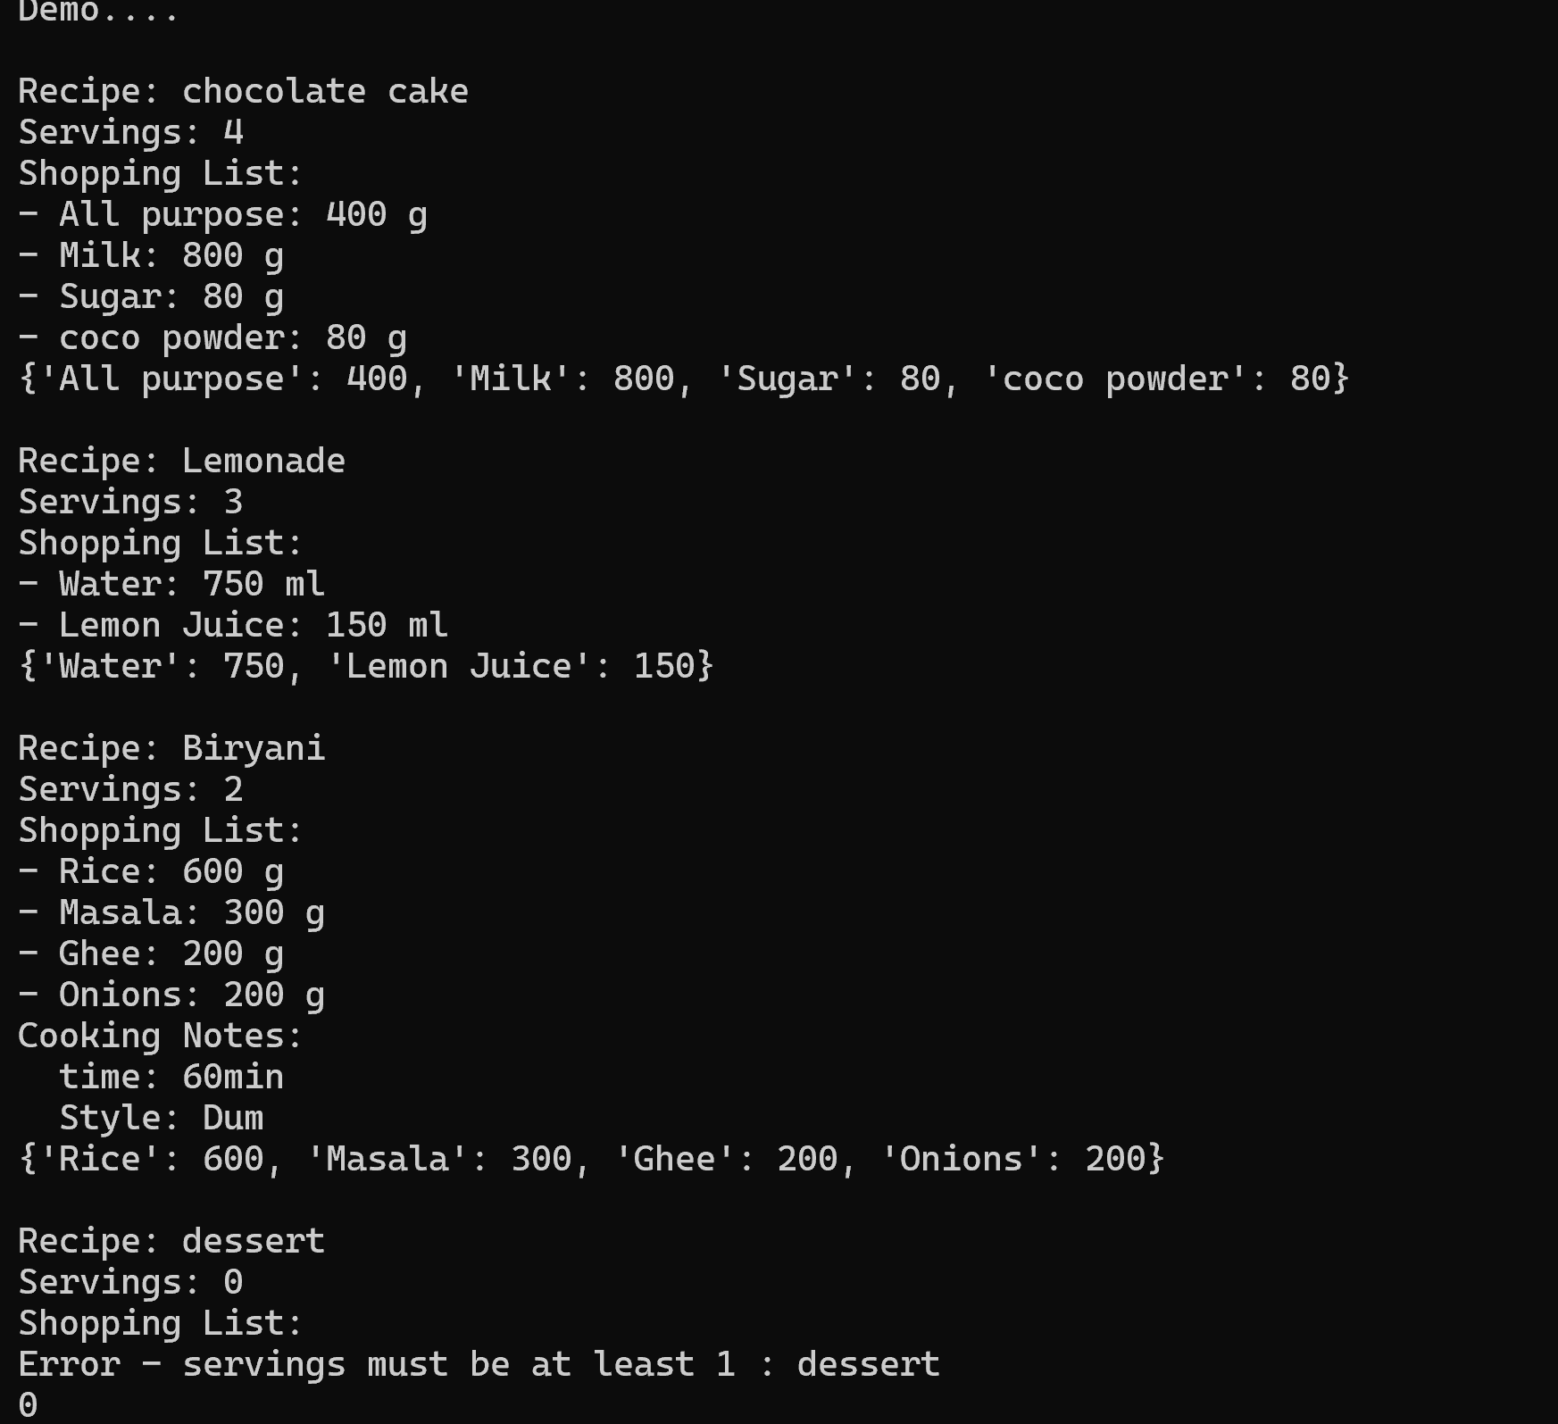
Problem ran into: printing ingredient formatting error and got them fixed.
Had to move the check condition on serving < 1 after the print recipe, otherwise its getting terminated without displaying the receipe details where serving <1

- Q4.py Library (Classes and Inheritance)
Approach :
- Created Super class Book that prints in nice required format and also checks for dups and calculates the age of book,
- Created subclass EBook that inherits super class Book which has additional attribute size_mb to calculate download time in seconds
- created class Library to store the books list, add books, find author , no.of books, oldest book
- Used super() to call the parent class constructor from the child class.
- Used (__str__, __eq__, and __len__) methods for printing in required format , duplicate checking, and counting books.
- Used a list to store books in the library class and a list comprehension to find books by a specific author.
- Used a for loop and conditional statements to identify the oldest book.
- Used datetime.now().year to calculate the current age of a book dynamically. For this , I have imported datetime from library

Demo Output:
print("Demo.... ")

print("\nAdding books......... ")

b1 = Book("1984", "George Orwell", 1949)
b2 = Book("Core Python Programming", "R. Nageswara Rao", 2007)
b3 = Book("Robotics, Vision and Control", "Peter Corke", 2011)
b4 = Book("Coming Up for Air", "George Orwell", 1939)
e1 = EBook("Python Basics", "John Smith", 2020, 25)
e2 = EBook("Data Science", "Jane Doe", 2022, 40)
duplicate = Book("1984", "George Orwell", 1950)

lib = Library()
lib.add(b1)
lib.add(b2)
lib.add(b3)
lib.add(b4)
lib.add(e1)
lib.add(e2)
lib.add(duplicate) # this will be ignored while adding

print("\nTesting......... ")
print(f"\nAge of {b1} : ", b1.age(datetime.now().year))
print(f"\nDownload time of {e1} : ", e1.download_seconds(20), "seconds")
print("\nBooks by George Orwell:")
for book in lib.find_by_author("George Orwell"):
print(book)

print("\nOldest book : " ,lib.oldest())
print("\nNumber of books in library : ", len(lib))
print("\nAll books in library :")
for book in lib.books:
print(book)
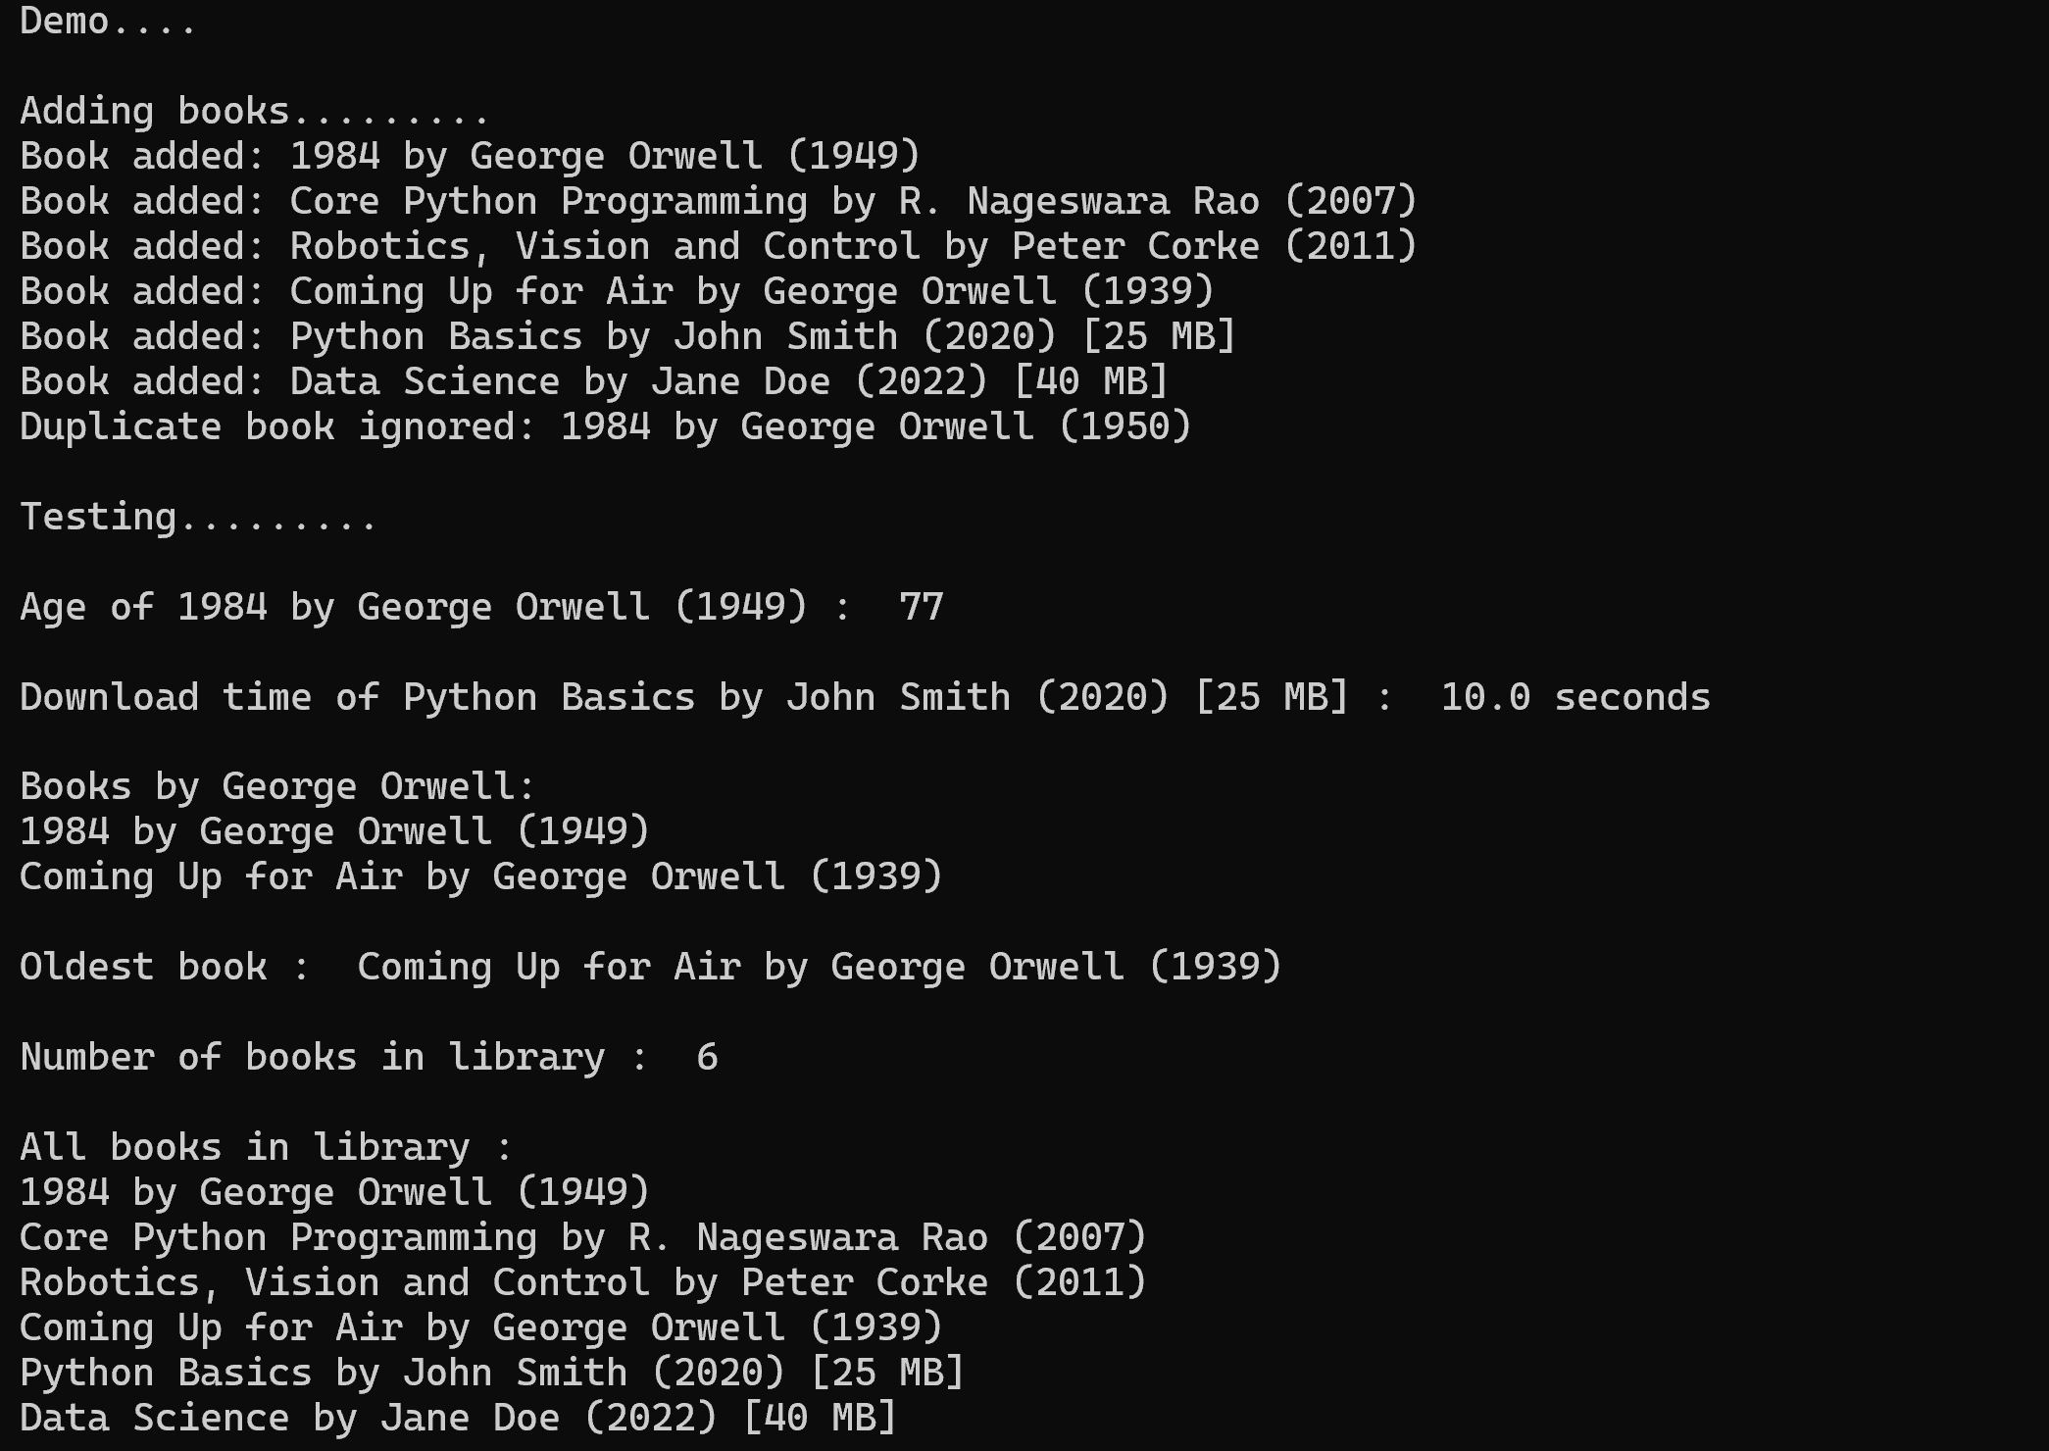

Problem ran into :
The duplicate book check in class Library below, printing both messages if we don’t specify the return . Without ‘return’ Python is continuing executing the remaining part.

def add(self, book):
if book in self.books:
print(f"Duplicate book ignored: {book}")
return ----- added this to avoid printing both messages.
else:
self.books.append(book)
print(f"Book added: {book}")

